(Approx. 614 words)

Six Little Word Problems and their Solutions
By Nancy DeMarte, 1st Vice President, Sarasota Technology User Group, FL
November 2018 issue, STUG Monitor
www.thestug.org / ndemarte (at) verizon.net

- You print a multi-page Word document and get an unexpected blank page at the end of the document. Because it has a footer, you won’t be able to use that sheet for anything except scrap paper.

Solution: Before you click Print, press the Show/Hide key on the Home tab > Paragraph group and scroll or press the Ctrl+End keys to get to the end of the document. You will see one or more paragraph icons on the last blank page. Select them and press Delete. Then save the document to avoid the blank page in future printings.

2. You open a document and find you have to squint to see the small type.
Solution: Go to the Zoom slider at the bottom right of the screen and click the + sign a few times until the document text is large enough to be comfortable for your eyes. This will not affect the text size when printed.

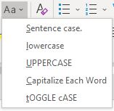
3. You are just about done typing a Word document and notice that all the text in the last couple of sentences is in upper case. You had pressed the Caps Lock key on the keyboard accidentally.

Solution: First select the text you want to reformat. Then click the Change Case tool (Aa) on the Home tab > Font group. Click the case pattern you want from the list, which in this situation is probably “Sentence case.”

- Sometimes you forget what version of Windows you have on your computer. “Version” includes the operating system (Windows 7, 8.1, or 10) and the Windows update version number, such as the recent update, 1803. But you’re not sure how to find the answer.

Solution: To find the version of your Windows operating system, type in the Search box at the bottom left of the taskbar the word winver. Then click the winver run command to see your computer’s details.

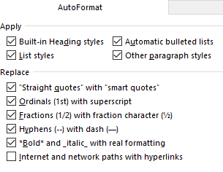
5. When you enter an email or web address in a document, by default Word automatically adds a hyperlink to the address. You can identify a hyperlink by its blue text and underline. Many times, you don’t want the hyperlink included.

Solution: There is a way to change the setting to stop the automatic hyperlink from being added.
Click the File tab (top left of the ribbon), then click Options (last item on the menu). Click Proofing > AutoCorrect options > Autoformat and uncheck the last item on the Replace list, “Internet and network paths with hyperlinks,” then click OK.

Just to be safe, also click “Auto Format As You Type” and uncheck the same box there, followed by OK.
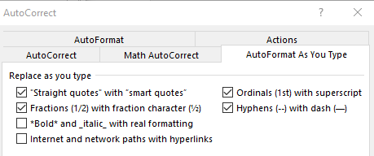
While you are in the Word AutoCorrect area, check to see if you are being bothered by any other automatic action. If so, uncheck it and click OK.

If you change your mind, return to this screen and re-check the boxes.

6. You have typed a long list of items, such as book titles, taking up several pages of a Word document. Each title is on a separate line. You would like to find out how many items there are in the list, but counting them would be tedious.

Solution: Select the entire list using Ctrl+A. Then on the Home tab - Paragraph group, click the numbering tool (top row, second from left) to place a number in front of each item. Then press Ctrl+End to jump to the end of the list, where you can view the last number. If you wish, then press Ctrl+Z or Undo to remove the numbering.

